NMR Spectroscopy 1

This is the first of 8 lectures on NMR. The course slides are found on www.mcgnmr.ca/kalle/404/NMR. Dr. Gehring mentioned that what he liked most about the two sections that he teaches in BIOC 404 is that most of what we see in this class is about electrons whereas he is going to talk mostly about nuclei. We covered mass spectrometry with quantum mechanics where charges were quantized. In other words, there are integers for charges. We’ll see quantum mechanics again in NMR but we’ll avoid it as much as possible. We’ll go right into the theory of NMR. You undoubtedly remember what a spectrometer looks like, where the signals come from and we’ll view a lot of basic trigonometry. Recall the equation sin²Θ + cos²Θ = 1. So we will try to simplify things by not talking about quantum mechanics but instead about vectors and magnetization which require trigonometry. In the second part of the NMR lectures series, Dr. Gehring will talk about how we assign signals and for this, the important part is how we’re going to assign a small peptide. The professor will show us two kinds of spectra and how we interpret those spectra to assign the resonances in a peptide.

NMR…why bother? Because it has many uses! There is a whole part of NMR which we will not talk about called solid-state NMR where people study polymers or surfaces. Lately, people have been looking at biomolecules like proteins and actually determine the structure of small proteins in a solid-state resin in solution which is what we are going to talk about. You probably first saw solution-state NMR in a chemistry course. It is used by synthetic organic chemists and by natural product chemists to determine chemical structures. We are going to look at biomolecular structural studies, how we determine 3D structures with emphasis on proteins and peptides. However, you can also use NMR to look at nucleic acids, nucleic acid/protein complexes or even polysaccharides.

Dr. Gehring’s lab uses NMR to study molecular interactions (recall the peptide binding domain and chemical shifts in spectra with peaks shifting when you bind a peptide e.g. the domain from poly(A) binding protein that we saw in BIOC 450). We can study ligand binding and look at how small molecules bind peptides. Magnetic resonance imaging (MRI) is part of NMR and looks at the nuclei of protons i.e. the only natural isotope of hydrogen. NMR may show promise in the ability to measure in vivo (e.g. in muscle) metabolites i.e. we can see the difference in muscle which is actively working versus its resting state. We can look at creatine levels changing which is done with phosphorus NMR.

There are many resources on the web about NMR. There is a site for the NMR part of Dr. Gehring’s lectures (the NMR is in capital and the rest is in lower case). There is also a set of practice questions for the theory part of the course and then two practice question sets for the peptide part. The professor suggests that we check the Hornak website because it is rather simplified. To see examples of how to assign peptides as we will do in the second half of the NMR lectures, check lecture 4 from the site from England. There are other resources which go from the simpler ones (Hornak) to the more NMR-sophisticated, NMR-quantum mechanically correct version (Keeler). Dr. Gehring’s lectures are modified versions of the ones by Moina.

NMR is about 50 years old. Its discovery led to the Nobel Prize by two physicists named Bloch and Purcell in the 50s. Then in 1991 in chemistry by Richard Ernst for Fourier transform in 2D NMR. Then about 10 years later, Kurt Wutrich received the prize for studying biomolecules. Just 3 years ago, the Nobel Prize was awarded to Lauterbur and Mansfield in medicine for NMR.

What do NMR machines look like? In Dr. Gehring’s slides, there is a picture of one at McGill. This is an 800 MHz spectrometer which costs about 3 million dollars. This one has a magnetic shield around it so you can only see part of it. The most important part is the super conducting magnet (2.5 million dollars). There are some electronics and a computer. What you don’t see is one of the most important parts i.e. the sample. Basically, the most important part of any biophysical experiment is the sample. Next thing we do is put the sample in a very strong magnetic field which will induce polarization of the nuclei (today’s topic). Then we use radiofrequency coils to measure the signal in the sample and then these go to a digitizer becoming digital signals. So they start off as radiofrequency signals

and then we change the frequency down to audio frequency electrical signals and then they get digitized (in an analog to digital converter) and then they go to a computer which is where we do the Fourier transform. In simple terms, we have the sample, a magnet and then radiofrequency electronics where we measure the signal.
So the sample is the most important part. However, the bad news about NMR is that it is a relatively insensitive technique. And so, 1) we need high concentrations of protein which is about 2-3 mM (this is about 1000X more than we need for optical spectroscopy!). With the newest equipment, we can reach down to 0.5 mM but that’s still several orders of magnitude than what you can do with optical spectroscopy or fluorescence. NMR is not a sensitive technique because the energy levels we are looking at are very small. 2) The sample has to be stable for a long period of time. Although NMR experiments can take just 15 minutes, we typically run experiments for a weekend or even 4-5 days and so you need long term stability. Samples can be run at room temperature (or even 15 ◦C). Furthermore, the isolated

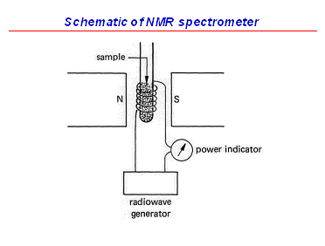
sample of proteins in solution can’t aggregate or change state. So we don’t want a mixture of samples to undergo glycosylation nor do we want the sample to oxidize during the process, we don’t want a mixture of reduced and disulfide cross-link proteins, protein samples can’t become deaminated (another post-translational modification). The last thing we’re going to see is the use of isotopes like carbon-13 and nitrogen-15 incorporated into proteins expressed in E. coli. In these bacteria, it is quite cheap to put in these isotopes (nitrogen-15 costs only 30$/L) whereas labeling proteins in tissue culture cells is very costly.
An NMR tube is as long as a pencil with about 0.5 ml of liquid in the bottom and sits in another tube (spinner) which then runs up and down the NMR spectrometer. At the top of the spectrometer, there is a little hole. Compressed air moves the sample up and down and then the region with the liquid rests in the middle of the 4 ton magnet. There are coils and capacitors for the radiofrequency electronics. The super-conducting magnet must remain at 4 ◦K (the boiling point of liquid helium). In order to avoid the boiling off of He (l), there is a giant door. Most of the space inside the spectrometer is insulation and the bath of He (l), in the middle there is a relatively heavy electromagnet inside which we have the coil containing the sample. During the last lecture, we will visit the pulp and paper building to see an NMR spectrometer.

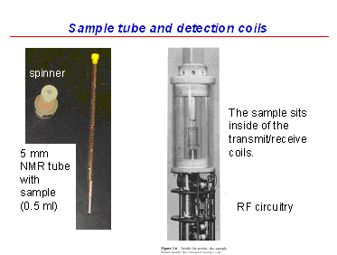

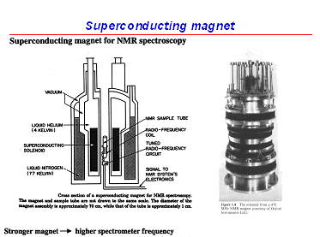
We have the sample, the coil, the super-conducting magnet and then cryogen (l). We use He (l) in the inner bath to keep the super-conducting magnet at 4 ◦K. Then we have liquid nitrogen on the outside to reduce the boiling off of He (l). At McGill, we have 500, 600 and 800 MHz spectrometers. With increases in magnetic field strength (measured in Tesla); the strength of the signal goes up linearly whereas the cost of these machines goes up exponentially. A 500 MHz spectrometer costs about 600 000$, 600 MHz – 1 million and 800 MHz – 3 million. At the University of OT, at the NRC, they have a 900 MHz spectrometer which at 6-7 million dollars. So to gain about 11-12% in the field, you double the cost of the machine. Nevertheless, you gain in resolution and field strength.

1 Tesla = 10 000 Gauss. To put this in perspective, the earth’s magnetic field is 0.5 G. Spectrometers are designed to have a very strong magnetic field in a small space. Dr. Gehring mentioned that the back-up resource to his lectures can be found on the Hornak website. We put our sample in the magnet and register a signal. But where do these signals come from? They arise from the magnetic properties of the nuclei because each nucleus is in fact a small bar magnet (although they are rather weak bar magnets which explains why NMR is so insensitive). The nucleus with the largest bar magnet strength (or gyro-magnetic ratio) is the proton and is itself so weak that it took scientists 10-20 years to detect the signal even after having predicted its presence. This lead to the Nobel Prize in 1952 we mentioned above where Bloch and Purcell detected the signal of a hydrogen nucleus bar magnet.
So if you look at a nucleus from a quantum mechanics point of view, it has a spin meaning that the nuclei are spinning. This can be used to justify why they have magnetic fields because nuclei are often charged (due to protons) and spinning. When you have charges spinning, you generate a magnetic field. This is similar to a current in a loop which will lead to a magnetic field. Just as the spin number of nuclei is quantized, the magnetic field of nuclei is also quantized. You can have nuclei with different spin numbers which greatly affects their magnetic properties. However, we look at the ones with the simplest quantum description which is two spin states, + ½ and – ½ corresponding to up and down. There are nuclei with integer spin states, you can get 1, 1 ½, 3 magnetic spin states and you can get even more

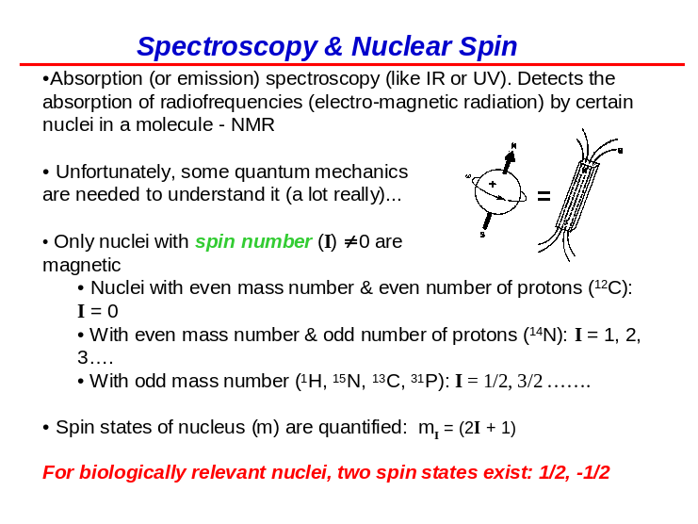
complex magnetic resonance spectra but they are not very useful for NMR of biomolecules. About the only one that is useful is nitrogen-14 which has a spin of 1. This particular isotope is used to detect bombs in airports. Impressively, you can actually detect a nuclear transmission in nitrogen-14 using radiofrequency of electronics and that’s how they screen bags for large amounts of nitrogen which makes up the bulk of most explosives. There are some rules for knowing whether we obtain a spin of ½ or not and depends on the number of protons and the total number of nucleons. If they’re both even, such as for carbon-12 (mass number is 12 and number of protons is 6) then you have no spin and therefore, no magnetic field. The ones we’re going to look at have an odd mass number ¹H, ¹⁵N, ¹³C and ³¹P.
When you put these bar magnets into an external magnetic field, B₀, there is a small energy difference where the nucleus is aligned with or against B₀. The energy difference, ∆E, depends on Planck’s constant, the gyro-magnetic ratio or γ (which is just the strength of the magnetic field of the nucleus), the strength of the external field and 1/2π. In the low energy state, they will be aligned with the magnetic field and in the high energy state; they will be aligned against it. It’s this small energy difference that we’re going to measure. In NMR samples, we have almost equal populations of these two states because the energy difference between the aligned and the anti-aligned is so small in terms of thermal energy meaning that these states are almost equivalently populated. This is completely the opposite

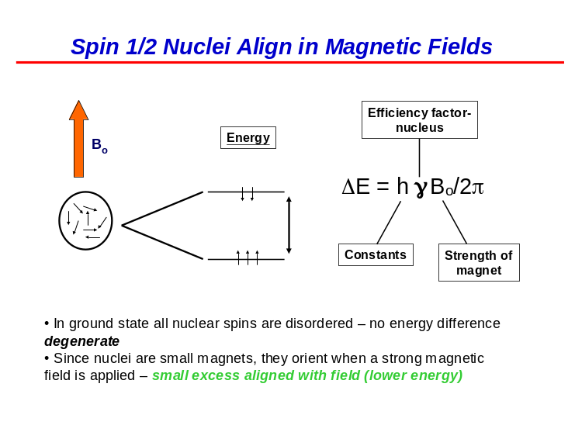
of optical spectroscopy where at the beginning of the experiment, electrons are not in the high energy state. NMR is relatively insensitive because we start off with a very small population difference between the two energy states.
So how do we detect our signal? Well we have our sample in the magnet and we have to let it equilibrate so that there is this small difference due to the external magnetic field (this takes a few seconds). Initially, the nuclei are randomly oriented and then over a short period of time, you’ll get a small equilibrium difference between the aligned and anti-aligned. Then we’re going to put in energy using radiofrequency and we’re going to invert our population difference.

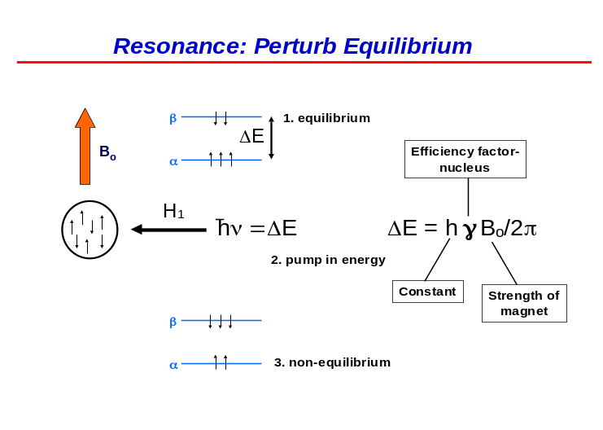
Then we’re going to let the system relax. It will tend to relax by emitting radiofrequency photons and return to equilibrium. This is how we’re going to detect, with antennae, the radiofrequencies emitted by the sample which will allow us to measure the energy difference. As mentioned before, the population difference is very small.

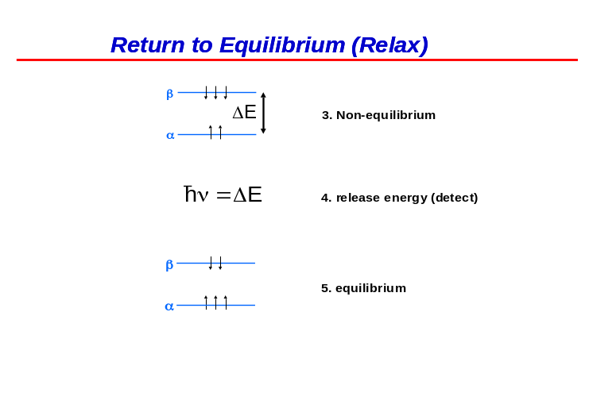

We write it in the form shown on the left describing the aligned against the anti-aligned. We use this Boltzmann equation to measure a population difference. In NMR, this ratio is very close to 1. It’s on the order of 1/10⁵ difference between the aligned and anti-aligned. Dr. Gehring gave an analogy where half the crowd in a stadium sat down and the other stood up with an extra person standing up. So in NMR, we don’t have many signals. One of the solutions is to look at nuclei that have large gyro-magnetic ratios which will increase the energy difference and so the population difference. You could moreover increase the strength of the magnetic field. Scientists spend so much money on acquiring large magnetic fields because as the energy gap increases, the population difference will increase.

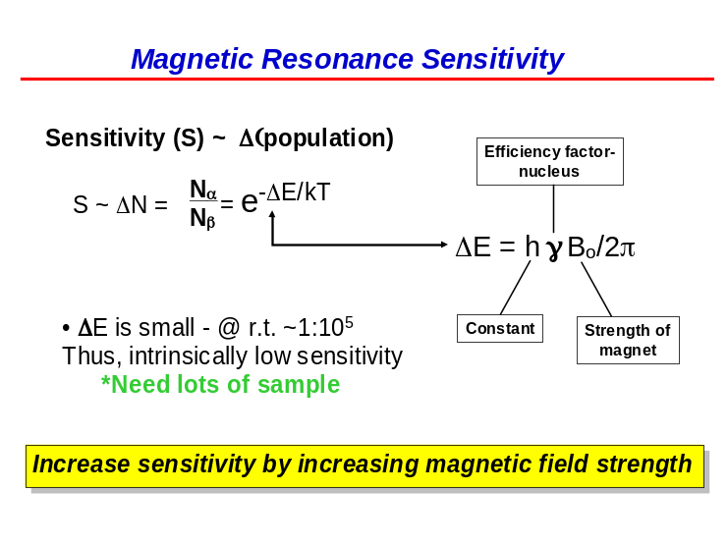
Planck’s constant with a bar through it means it is divided by 2π. A photon’s energy is proportional to its magnetic field and the strength of the magnet so that in a higher magnetic field, we not only increase the energy difference between the two populations but we notice that the frequency of the photons depends linearly on the magnetic field strength. Therefore, one way to measure the magnetic phenomenon is to measure the energy difference and then convert that into the wavelength of the photon. There is another way using classical mechanics and physics to consider the nuclei as spinning bar magnets, which when placed into B₀, cannot flip due to their spin. They are like precessing tops. When the magnetic nucleus is in B₀, it spins like a top and the frequency at which it precesses is the same as the frequency of the emitted photon. Swell!

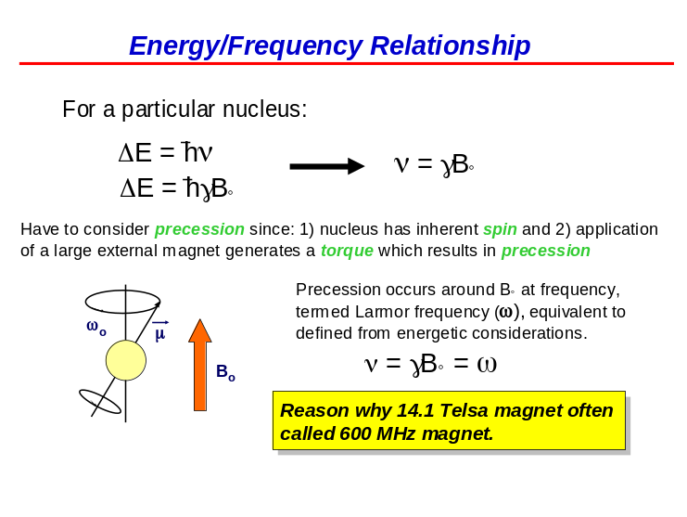
So to recap, the four nuclei we will study the most are 1) ¹H – which have the largest gyro-magnetic ratio, 2) ¹³C, 3) ¹⁵N and 4) ³¹P. It is important to remember the ratios of these atoms. In NMR jargon, we don’t talk about a magnet at a certain number of Tesla, what we refer to instead is the frequency of a proton in a magnetic field. At McGill, we have a 600 MHz spectrometer which therefore has a magnetic field of 14 Tesla at its center or 140 000 G. However, the easiest way to talk about this is to remember that a proton precessing in that magnetic field precesses at 600 MHz which is a short radiofrequency wave. ¹³C’s gyro-magnetic ratio is four times weaker than that of ¹H so its frequency is only 150 MHz. ¹⁵N is 10 times weaker and ³¹P is about 40% relative to ¹H. The other thing that

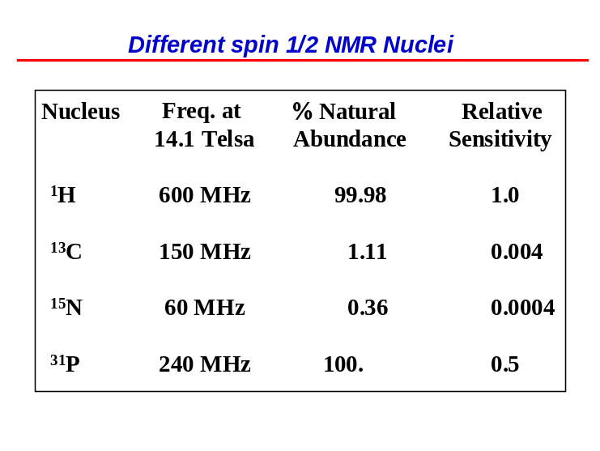

is of importance is the natural abundances. Almost all of hydrogen is of the form ¹H whereas ¹³C and ¹⁵N are relatively rare. This is why when we want to use these nuclei to study biomolecules, we grow bacteria is ammonium salts containing ¹⁵N (which is relatively cheap) or ¹³C-glucose where are the carbon atoms in the glucose molecules are ¹³C. This way, we can get the protein grown in bacteria to be labeled with either isotope at every position.
So this is what we’ve seen so far. We’ve got our tangled up nuclei. When we put them into a magnetic field, quantum mechanics tells us that they’re either going aligned or anti-aligned to the magnetic field. There is a small population difference which we can manipulate with radiofrequency fields to measure it and the fact that we have this difference in populations is going to give rise to a bulk magnetization of the sample. For example, if you put a solution of water into a magnetic field, the water gets slightly polarized and there is a slight magnetic field from the water felt in the magnetic field but it’s very weak and that’s why we don’t consider water to be magnetic. But there is a slight bulk magnetization of the water that occurs and we measure this. We don’t detect the individual transit-

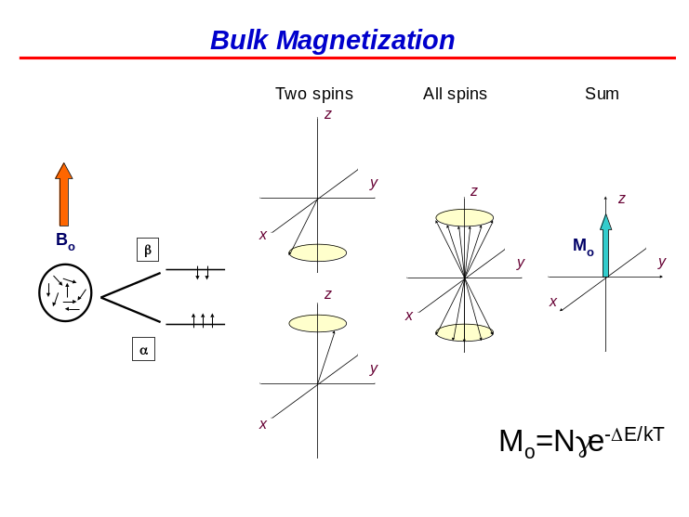
ions, we detect instead bulk magnetization which we can manipulate with radiofrequency fields. We use arrow-type representations to show bulk magnetization and this will involve trigonometry. So we usually place our sample in the magnet, give it a few seconds to equilibrate and get a bulk magnetization and we then use radiofrequency pulses to move it around.
When you put your sample in a magnetic field, you get bulk magnetization which is going to be aligned with the z-axis because that is where your magnetic field is. We assume that the external magnetic field, B0, is on the z-axis. Using the right-hand rule, if the bulk magnetization is along the x-, y- or z-axis, we obtain the vectors oriented in the directions shown on the slide. They can also be written as I^{x}, I^{y} and I^{z}. We will study how we move our magnetization between various axes. So magnetization on the z-axis, I^{z}, is at equilibrium. We can have magnetization on the x- or y-axis as well as a combination where we have ½ on the I^{x} and ½ on the I^{y} to get √2I^{x} + √2I^{y} where we have the square roots because we keep our vectors at unit length. We could have any linear combination of the vector on

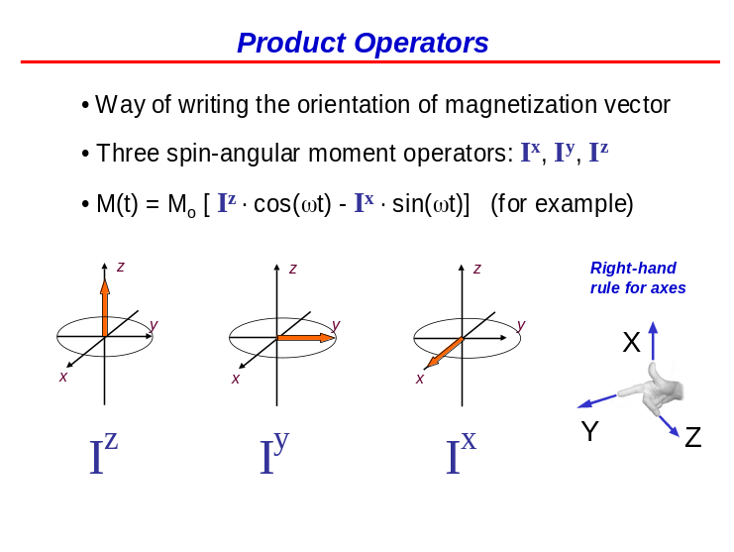
particular axes. Keeping the vector at unit length, we also have an angle omega, ώt.

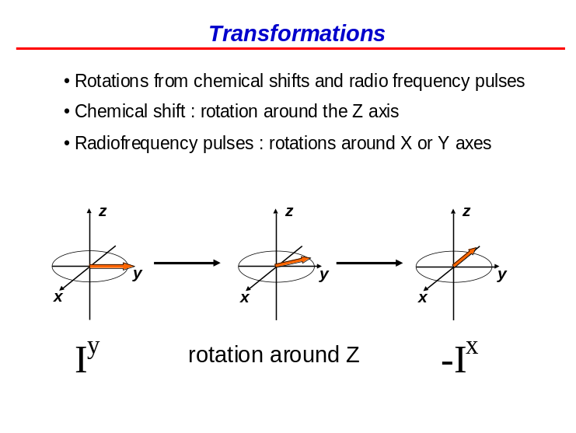
There are two ways that magnetization moves from one axis to another. First, when we perturb the system we invert the magnetization by using radiofrequency (RF) pulses or electromagnetic fields. We move I^{z} → I^{x} or I^{y} or a combination of these. These basically move anything from the “north pole” down to anywhere else on the “globe”. We could even move the vector down to the “south pole”, or –I^{z}. These are rotations off of the z-axis. Second, chemical shift (i.e. the frequency differences between nuclei) will move magnetization from I^{x} → I^{y} etc. and I^{y} → I^{-x}. In the slide, we show the magnetization starting off in I^{y} and because of a chemical shift; it’s going to rotate in the x-y plane and reach the –x axis. It rotates at a speed of ώ and the time it takes is t. So the angle is ώt. We then measure NMR

frequencies by assessing how fast they rotate in the x-y plane i.e. ώt. We start off with magnetization in the y-axis and at time t, we end up with I^{y}cos(ώt) – I^{x}sin(ώt). In the next lecture, we will look at the rules for how magnetization moves along the three principal axes. Basically, cos is where you came from and sin is where you’re going. At time = 0, the above equation simplifies to just I^{y}. When ώt = 90◦ or π/2, we obtain –I^{x}.
We define positive chemical shift as counterclockwise (CCW). For example, we start off in I^{x} at a time t. I^{x} is going to precess into I^{x}cos(ώt) – I^{y}sin(ώt). The tricky part is remembering the signs. Here, CCW rotation puts you on the z-axis. Using the right-had rule, I^{x} → I^{y} and I^{y} → -I^{x}.

